**NextGen**

**Non-Financial Data Migration Guide**

**Introduction** **2**

**General Pre-Migration NextGen Setup** **3**

**Populating Import Templates** **4**

**Importing Into NextGen**  **5**

Resolving Errors & Warnings **6**

**Sign Off Checklist** **10**

# 

# Introduction

This article is to walk you through the migration of non-financial information from another program if you wish to perform these steps yourself. Review our [Link](https://www.cosmolex.com/documents/dm/Non-Financial-Data-Migration-Guide.pdf) for complete details.

NextGen provides comprehensive instructions and a variety of tools so you can complete your non-financial data migration. Contact us if anything is not clear. If you do not have time or resources to perform the migration, NextGen along with its certified partners can also provide a turn-key migration service for a fee. If you would like to learn more about our data migration, contact your NextGen Account Manager to schedule a free data migration consultation call.

You can migrate a variety of non-financial data such as **Clients, Matters, Contacts**. This guide will provide a general overview of the migration process.

**Important Notes:**

* Ensure you have the latest version of this guide available at: [Link](https://www.cosmolex.com/documents/dm/Non-Financial-Data-Migration-Guide.pdf) (clear your browser cache). You can compare the “Last Edited” date in the footer section.
* Download the latest version of the Non-Financial Import Template available at: Link (clear your browser cache). You can compare the “Last Edited” date shown in the 1st tab of the excel.

# 

# General Pre-Migration NextGen Setup

Ensure you have the following setup in your NextGen account:

1. **Trust Banks** - by default NextGen provides a bank named ‘Trust Bank’, you can rename this and add additional accounts to your system under Banking. These are the accounts you will map your matters to. NextGen also allows mapping multiple Trust Banks to a Matter if that’s needed.
2. **Operating Banks -** by default NextGen provides a bank named “Operating Bank”. You can rename this and add additional accounts to your system under Banking. Use this account type for any sort of General or Business accounts.
3. **NextGen Users** - Ensure to add NextGen users under the Account section prior to import.To add users in NextGen follow the below steps  
   Click on Initial letters of your account name at top right corner > Under Account > Account Management > Add.  
   Under User tab, you can add, edit and delete users, as well as the Role tab, where you can add, edit and delete user roles. This area is only accessible to those who have proper permissions.

**Matter Owners** – When adding a User, the system will also add this individual as a Matter Owner. In the Add User window, you will see the Matter Owner Settings for review and updates. The matter owner is the lawyer responsible for administering the case. Naming a matter owner helps you organize matters and generate reports.

**Default Matter Owner** - During the import, if no matter owners are assigned, or does not match someone within your system, the default matter owner will be chosen. You can select/confirm this default under Setup > Firm Settings > Firm Preferences.

**Timekeepers** - A timekeeper is the person who is assigned to a particular time or expense entry. When adding a User, the system will also add this individual as a timekeeper.   
  
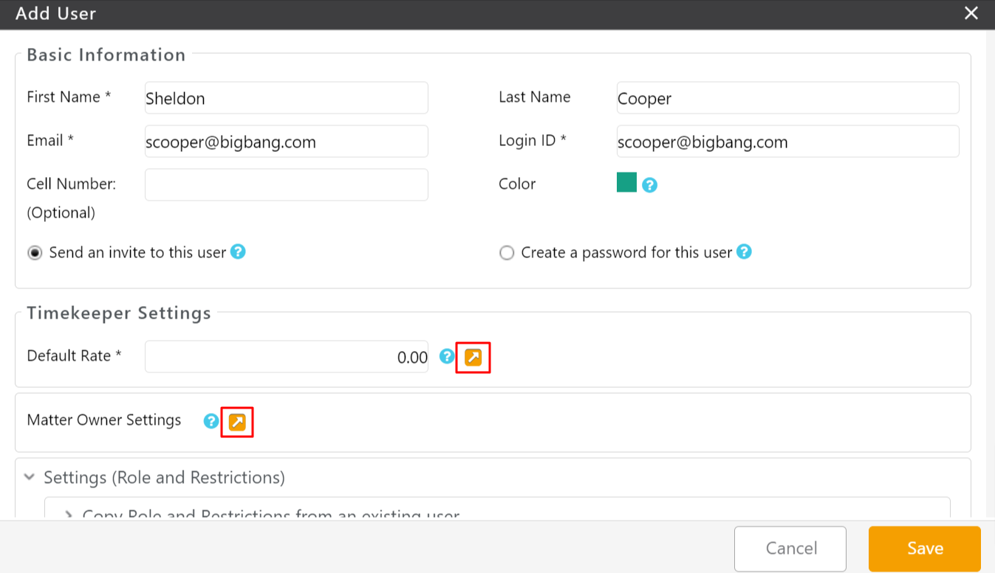

# Populating Import Templates

You can export a variety of data from your legacy system and place it into our provided NextGen matter import template. You can locate the template and instructions [Link](https://www.cosmolex.com/documents/dm/cosmolex-matter-import.xlsx)**.** NextGen or its certified consultants can guide you in extracting and re-formatting the data into this template.

**Note: The best way to go about copying all your contact/matter data into our data import template would be to copy a column at a time from your spreadsheet and paste the data into the correct columns in our data import template. Copying all data at once from the spreadsheet into our data import template will result in an error message.**

Be sure to name the import file and save it to your desktop.

NOTE:

* Client Naming convention is a single column containing: “first name last name”.
* It is best not to use any special characters in the name, e.g. *, ^, #, etc.
* Use “TRIM” on all columns to ensure no space before first letter
* Remove unnecessary columns before import

# 

# Importing Into NextGen

1. Log in to NextGen
2. Click on the “+ Quick Action” on the top right corner, and in the drop-down menu, select “Import Data”.

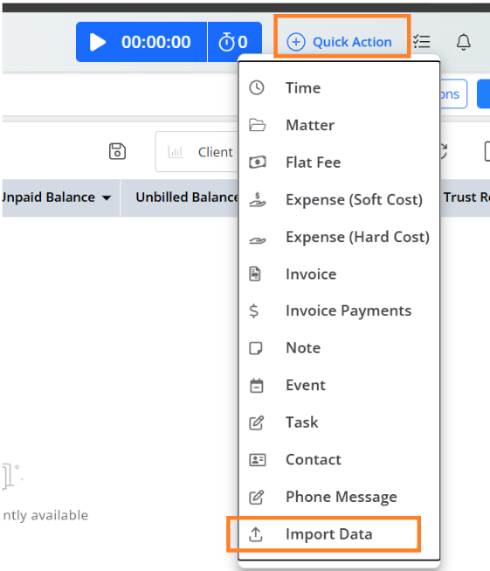

1. On the next screen, select the type of data you wish to import, below we used the example of importing Clients/Contacts.

1. Click on "Upload file" and browse to the excel file you have already created. Select that file, then click “Upload”.

The next window is a **temporary area** in which any issues with the data can be addressed PRIOR to import.

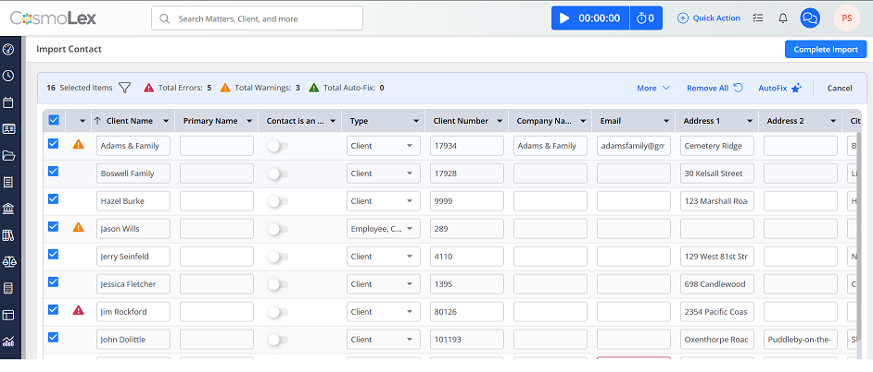

## Resolving Errors & Warnings

On this screen you will notice in the top area the counts of total Errors (red), Warnings (yellow) and Auto Fix items (green)

**Errors** - Items that need to be addressed and fixed prior to import

**Warnings** - Issues which the import identifies and can correct for you

**Auto Fix** - Those items which were already fixed by the system

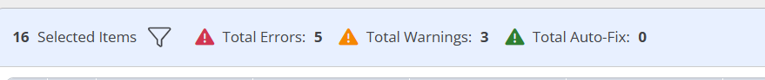

**Locating Error Details**

On the top of the window, you will find a filter option. Click on that to expand the filters. You can use these filters to locate specific items, or filter by warnings, errors, etc.



To see details of the errors or warnings, click on the Caution Symbol to the left of the item listed.

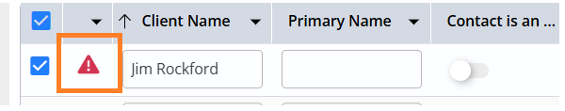

A pop-up will then display, explaining the issue(s)

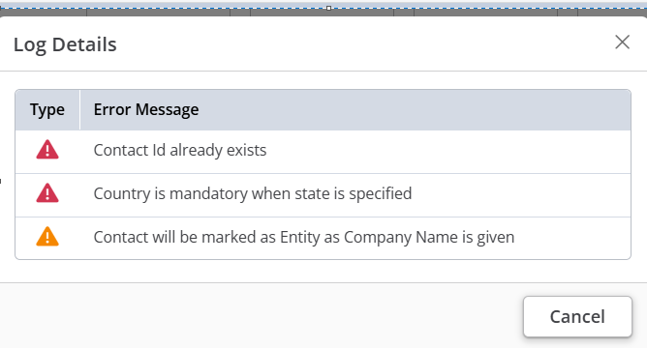

For this item, there are a few issues listed:

**Warnings** (yellow) - Relates to missing or invalid information for certain fields. If you were to use the Auto-Fix function, you are agreeing to the fixes described here.

**Errors** (red) - This is something that is required, yet the program cannot make this fix for you. In this example, I am missing the client name.

Once you understand the errors, exit the log details window to get back to the data list.

**If you do not agree to these fixes and therefore do not want to import this item, you can uncheck the item from the import list.**

Since it is possible to have multiple errors that need to be resolved, the “More” menu at the right side provides various features to make bulk edits to your data right within this temporary area.

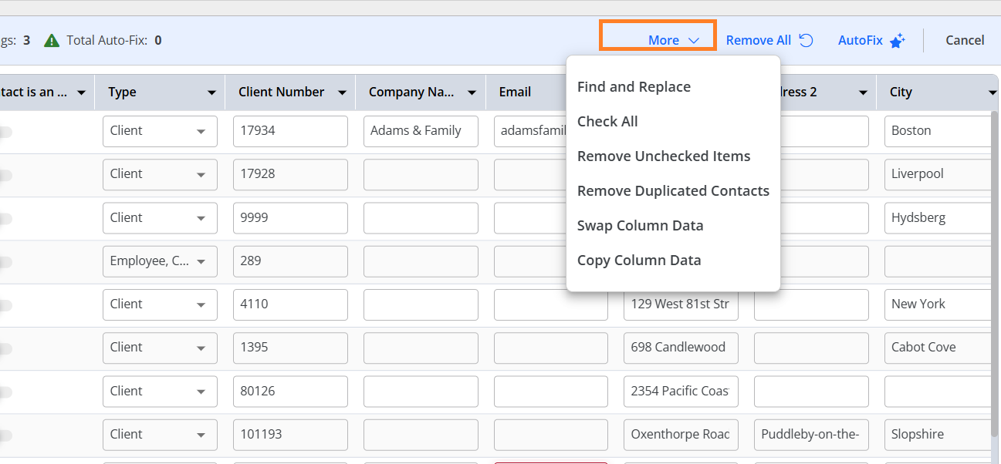

* For missing data (ex: missing client name) you will need to locate the record and type in the missing information.
* You could use “Find and Replace” or “Swap Column Data” to apply bulk updates.
* You could also use other logical functions such as “Remove Duplicated Contacts” if your data requires those cleansing edits.

**You do not have to fix all of your data in one sitting. To leave, click CLOSE at the top right. Your data will still be there for review. No data is yet imported into NextGen.**

In the future, to get back to the import screen, again Click on the “+ Quick Action” icon on the top right corner, and in the drop-down menu, select “Import Data”. The sections that are in progress will be named as “Continue with…”

If for whatever reason you wish to remove the data from this temporary area (perhaps start over). Click the “Remove All" button at the top next to the action menu. This will not affect your NextGen data, as nothing was yet imported

**Using Auto-Fix**

Once you have resolved all the errors (red icon), you can click “Auto-Fix” in the top left corner to automatically resolve any remaining warnings. These warnings are usually due to missing or mismatched data which can be corrected automatically by assigning your NextGen system defaults.

As mentioned above, you can click on the warning icon for details. If you do not want the system to auto-fix an item we suggest either manually fixing the warning to resolve it, or unchecking that item so it will not be auto-fixed or imported

Once you click YES, you will see any warning symbols now turn green (for auto-fixed) and the summary at the top will update.

**Completing Import**

Once all errors and warnings are resolved, you can then complete the import by clicking the "Complete Import" Button at the top right.

You will need to complete these steps for each sheet within the non-financial import template that has data you wish to import.

You will need to set up Import settings for Matters. This designates how the Matters will be linked to the Contacts that you have already imported. You need to save the Contact Matching Criteria before proceeding further for Matters.

Below are the Contact Matching criteria while importing the Matters, you can select any of them and link your matters.

* Contact Name- Client Name
* Contact Import Identifiers- which are internal identifiers that you have from your prior programs, are used to link Contacts.
* Client ID- Client Number
* Client Index# - These are NextGen generated serial numbers

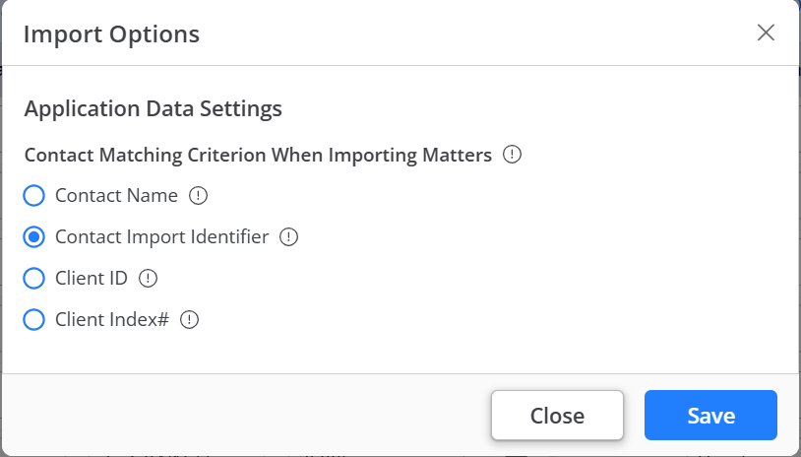

# Sign Off Checklist

* Verify # of Contacts, and Matters imported into NextGen matches with your Legacy Software.
* Spot check some Contacts and Matter to ensure all imported information is displayed in the appropriate fields.