NextGen

Financial Data Migration Guide

Introduction 2
Common Tips 2
General Pre-Migration NextGen Setup 2
- Migration of WIPs entries 3
  - Prerequisites 3
  - Export Legacy WIP entries 3
  - WIPs Entries 3
  - Section Sign Off Checklist: 6

Introduction
Financial data migration consists of 2 main sections. Unbilled Time and Unbilled Expense (Work In Progress)

Important Notes:

  - Ensure you have the latest version of this guide available at: Link (clear your browser cache). You can compare the “Last Edited” date in the footer section.
  - Download the latest version of Financial Import Template available at: Link (clear your browser cache). You can compare the “Last Edited” date shown in the 1st tab of the excel.

Common Tips
Importing financial data requires expertise in extracting data from legacy systems and ensuring proper formatting prior to starting the import. Most of this is performed in excel files. In general, prior to starting the import, you may want to keep following excel guidelines in mind:
  - Use “TRIM” on all columns to ensure no space before first letter
  - Client naming convention: (single column containing: “first name last name”)
  - Find and replace special characters
  - Remove unused or unnecessary columns before import
  - Use “Yes/No” or “True/False” for cleared status
  - Cells where amounts are “0” should be left blank; Don’t enter as zero.

General Pre-Migration NextGen Setup
This section outlines NextGen setup which must be completed prior to starting any of the financial migrations listed in this guide.
  - Review/Add your Timekeepers (Setup > Timekeepers)
  - Review/Add your Matter Owner's (Setup > Matter Owners)
  - Review/Add your Bank Accounts (Accounting > Banks)
  - Complete global accounting selections (Setup > Firm Settings > Accounting Settings)
    - Select appropriate client cost account by billing type
  - Your non-financial data (Client & Matter information) must be successfully migrated into NextGen. Link to learn more about NextGen’s non-financial data migration service.
  - Update Chart of Accounts with Firm specific ones, if any (Accounting > Chart of Accounts)

Migration of WIPs entries
This section will walk you through the migration of your billing balances (accounts receivable) from another program.

Prerequisites:

- You have completed/reviewed steps as listed in General Pre-Migration NextGen Setup
- Your billing must be completed for the month prior to your billing closing date.
- Ensure a default timekeeper is selected within the program (Setup > Firm Settings > Firm Preferences). As any WIP entries not assigned to a timekeeper, will be auto assigned to the default timekeeper

Export Legacy WIP entries

- Choose a “Billing Closing Date”, which is normally the last date of the current month.
- Continue to enter your Timecards and Expense Cards in your old system as usual up to the Billing Closing Date.
- Once the closing date has arrived, issue your client invoices for work/expenses from your old system for as many matters as possible through your Billing Closing Date. This avoids the need to manually enter any work-in-progress (WIP)”
- NOTE: After the Billing Closing Date and going forward, enter ALL of your time and expense cards in NextGen only.

WIPs Entries
- Any fixed fee or contingency matter’s unbilled fee or costs as well as any WIP entries post Billing Closing Date can be imported into NextGen using financial data import template located HERE.
1.Log in to NextGen
2. Click on the “+ Quick Action” on the top right corner, and in the drop-down menu, select “Import Data”.
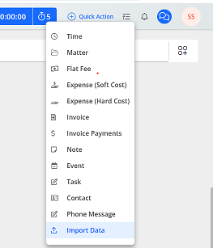

On the next screen, select the type of data you wish to import, below we used the example of importing
Time/Expense.
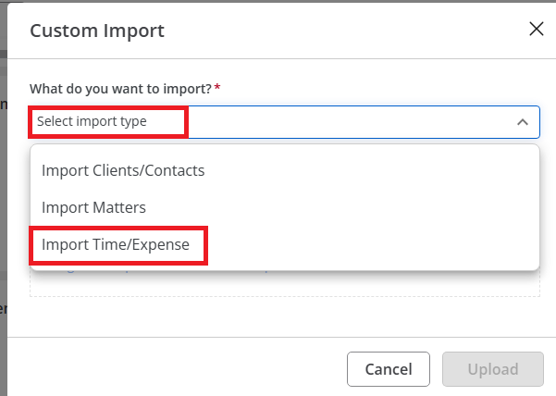

Click on “Upload File” and browse to the excel file you have already created. Select that file, then click
“Upload”.

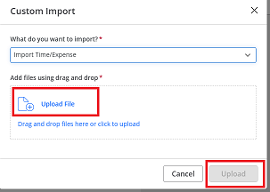

On the next screen you will get data which will be imported and if there are any issues we can resolve prior to import.
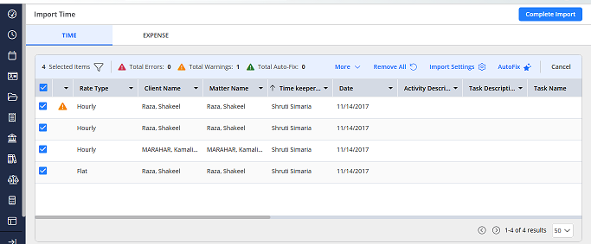

Resolving Errors & Warnings
On this screen you will notice in the top area the counts of total Errors (red), Warnings (yellow) and Auto Fix
items (green)
Errors - Items that need to be addressed and fixed prior to import. This is something that is required, and the program cannot make this fix for you.
Warnings - Issues which the import identifies and can correct it self. Relates to missing or invalid information for certain fields. If you were to use the Auto-Fix function, you are agreeing to the fixes
described here
Auto Fix - Those items which were already fixed by the system.

On the top of the window, you will find a filter option. Click on that to expand the filters. You can use these
filters to locate specific items, or filter by warnings, errors, etc.
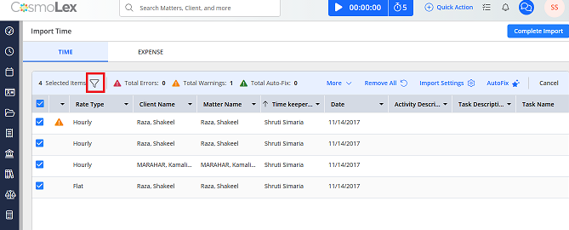

By clicking on Error icon you will get detailed information of the error, warning so that you can resolve the same accordingly.
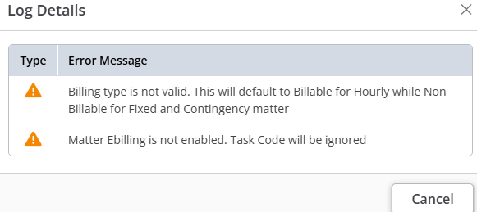

Section Sign Off Checklist:
❏ Run Pre-Bill Report in NextGen, “Exclude Billed Items”
❏ Match legacy WIPS by matter to Pre-Bill Report by Matter in NextGen

